Order Placing Guide – iPECS Portal

👤 Create New Customer
• On the left-hand navigation panel, go to the "Customers" drop-down menu.
• Select "Create New Customer".

📝 Enter Customer Information
• Fill in the required customer information fields, such as Customer Company Name, Domain, Language, Customer Type, and Reseller.
• Scroll down to the "Billing Account" section.
• Click the "Add" button to create the billing account on the IPECS portal.
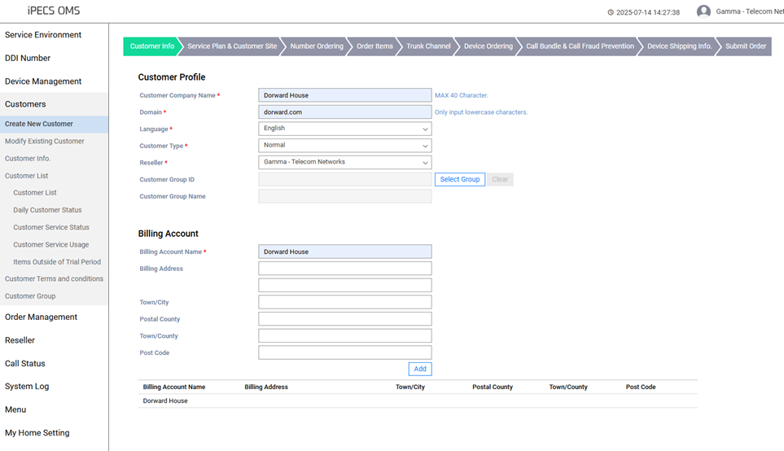
• Scroll down to the "Administrator" section and enter a generic admin username and password.
- Format: adminuser@(customersdomain).com
- Password: 01(CustomerName)01
• Click the green "Next" button at the bottom right.
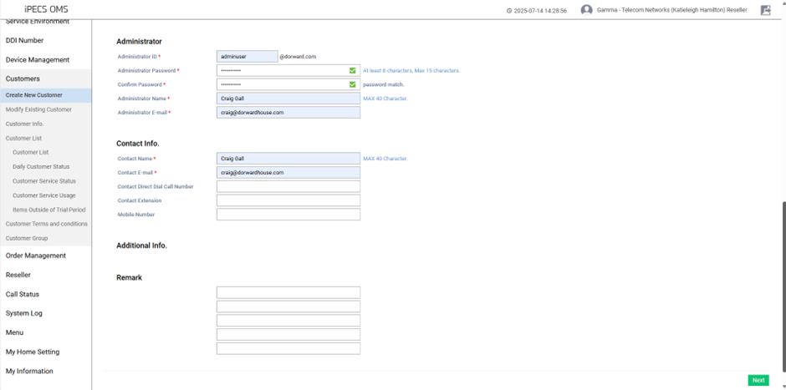

🏢 Complete Customer Site Information
• Fill in the "Customer Site" details.
• Select "TRUE" for the Main Site.
• Click the "Add" button to save the site information.
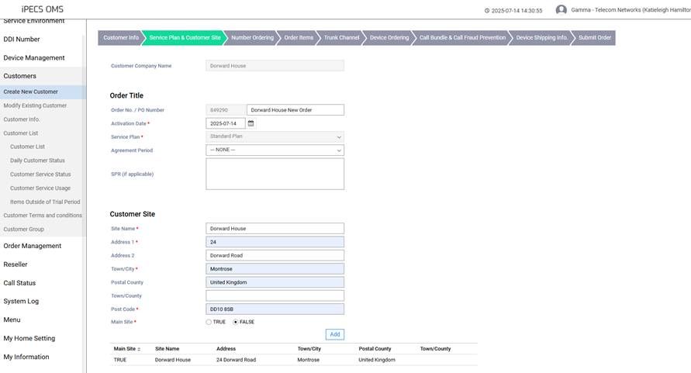

📞 Number Ordering
• In the "Number Ordering" section, select the number of CLI’s being ported and any additional DDI’s required.
- Example: For 8 phones, order 9 numbers (1 Main Incoming + 8 DDI numbers).
• Add a note specifying:
- The CLI being ported to iPECS.
- Whether additional DDI’s are required and include the dialing code.
• If no additional DDI’s are needed, no note is required.
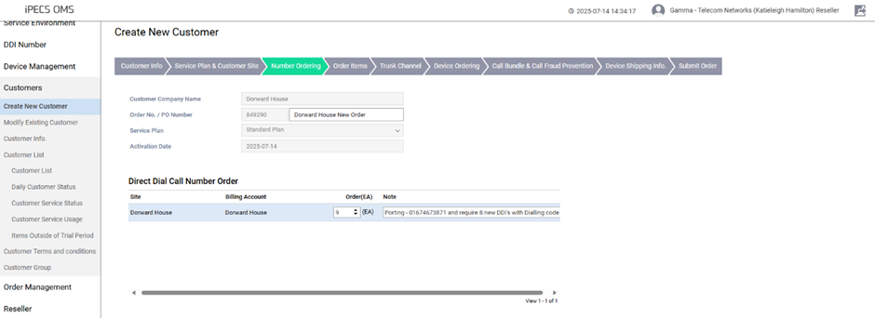

🧾 License Ordering
To order the correct licenses, use the references below:
• IPC-WH-iPECS3-HW: 3 Year iPECS POWER Subscription with £115 hardware credit – Power License
• IPC-WH-MUL-LITE: Monthly Subscription - Basic, no inclusive minutes – Lite License
• All licenses should be ordered on a three-year term unless the salesperson states otherwise. Lite licenses are on a monthly rolling
Input the quantity in the space provided:
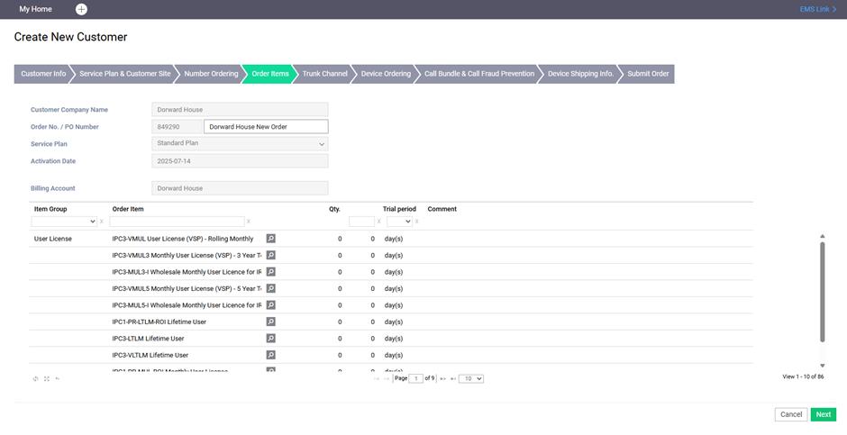
Place a SIP Trunk order for every user – e.g., 8 users = 8 SIP Trunk Channels.
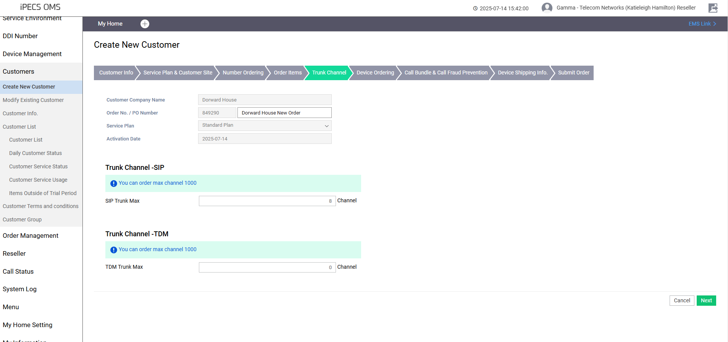

📞 Device Ordering
In device ordering, we are always ordering 1020i's as iPECS handsets. If cordless handsets or any other model are required, check with the salesperson for the model and price.
Click 'Next'.

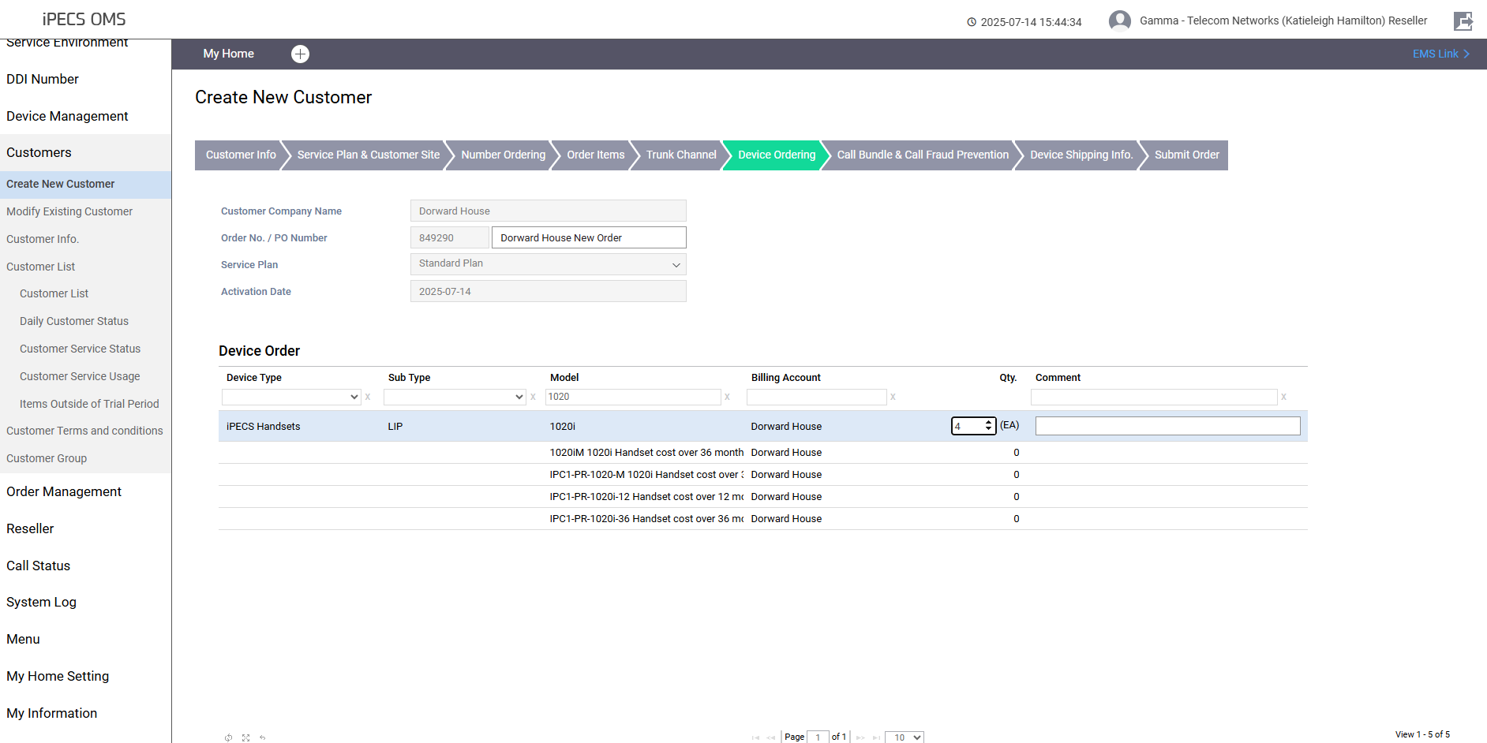
Call bundle and fraud prevention are pre-filled. Click 'Next'.
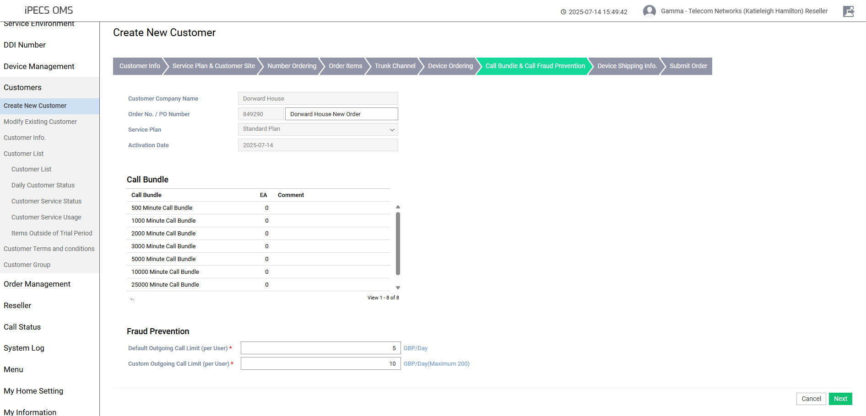

Device shipping info:
• Enter the customer’s address if phones are going straight to site.
• If engineers are installing the phones, input Telecom Networks' details.
• Scroll to the bottom of the page to input what handsets are to be shipped to which site.
• If all handsets are coming to the site, enter the full amount under the delivery site.
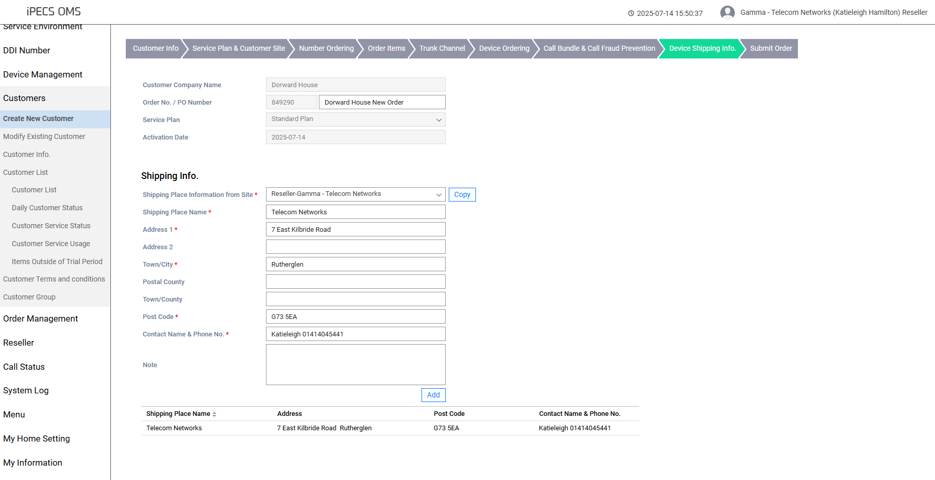
✅ Check all order details and submit the order.
Once the order is submitted look out for the order final confirm which will be visible on the portal on the left-hand side under Order Management -> Order Final Confirm -> Locate order -> Scroll to the bottom of the page after ensuring all details are correct and press “order final confirm”
